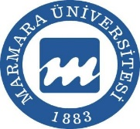 MARMARA UNIVERSITY 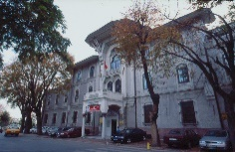

Key Data
University | Marmara
ERASMUS code | TR ISTANBU05
EUC | 221719-IC-1-2008-1-TR-ERASMUS-EUCX-1
Address | There are 8 campuses
Web-page | www.marmara.edu.tr
Rector | Prof. Dr. Mehmet Emin OKUR

Erasmus Unit

Institutional Coordinator: Prof. Dr. Nuri TINAZ
Address | Marmara Üniversitesi Uluslararası İlişkiler ve Akademik İşbirliği İktisat Fakültesi İbrahim Üzümcü Konferans Binası Kat:2 Göztepe Kampüsü 34722 Kadıköy/İstanbul
Phone number | +90 216 777 1750
Fax | +90 216 777 1751
E-mail | erasmus@marmara.edu.tr; erasmus.incoming@marmara.edu.tr;
Web-page | http://uluslararasi.marmara.edu.tr  http://international.marmara.edu.tr

Erasmus+ Coordinator: Asst.Prof. H. Gökçen ÖCAL ÖZKAYA
Address | Marmara Üniversitesi Uluslararası İlişkiler ve Akademik İşbirliği İktisat Fakültesi İbrahim Üzümcü Konferans Binası Kat:2 Göztepe Kampüsü 34722 Kadıköy/İstanbul
Phone number | +90 216 777 1772
Fax | +90 216 777 1751
E-mail | erasmus@marmara.edu.tr; erasmus.incoming@marmara.edu.tr;
Semesters | Beginning of October-Beginning of January: 1st Semester.  January-February: Final and Make-up Exams  End of February-End of May: 2nd Semester.  June-July: Final and Make-up Exams  http://takvim.marmara.edu.tr/
Application deadline | Fall Term: 15th of June  Spring Term: 15th of December
Accommodation | Private (renting/sharing a flat)
Language course | Turkish language course will be offered

